BHARATI VIDYAPEETH COLLEGE OF ENGINEERING

DEPARTMENT OF INFORMATION TECHNOLOGY ACADEMIC YEAR: 2020-2021

COURSE NAME: INTERNET PROGRAMMING LAB

|  |  |  |  |  |  |  |  |  |
| --- | --- | --- | --- | --- | --- | --- | --- | --- |
| **COURSE CODE** | | | **ITL501** | | | | | |
| **ASSIGNMENT NO.** | | | 1 | | | | | |
| **ASSIGNMENT TITLE** | | | **Mini Project** | | | | | |
| **NAME OF STUDENT** | | | Shubham Surve, Abhinav Tiwari, Akash Vhotkar | | | | | |
| **ROLL NO.** | | | 64,67,71 | | | | | |
| **CLASS** | | | **TE-IT** | | | | | |
| **SEMESTER** | | | **V** | | | | | |
| **PERFORMANCE DATE** | | |  | | | | | |
| **SUBMISSION DATE** | | |  | | | | | |
| **CORRECTION DATE** | | |  | | | | | |
| **REMARK** | | |  | | | | | |
| **TIMELY SUBMISSION** | | **PRESENTATION** | | | **UNDERSTANDING** | | **TOTAL MARKS** | |
|  | **02** |  | | **02** |  | **06** |  | **10** |
| **NAME& SIGN. OF FACULTY** | | **Prof.S.N.Patil** | | |  | | | |

**Assignment 1**

**Aim:** To create website using html5,css,javascript

**HTML**

1) Miniproject.html

<!DOCTYPE html>

<html lang="en">

<head>

<meta charset="UTF-8">

<meta name="viewport" content="width=device-width, initial-scale=1.0">

<title>Sport Corner</title>

<link rel="stylesheet" type=text/css href="css.css">

<script src="https://kit.fontawesome.com/5c174d451e.js" crossorigin="anonymous"></script>

</head>

<body>

<header class="showcase">

<h1></h1>

<button href="p14signinform.html" class="btn"> <a href="sighin.html">Sign in</a> </button>

<div class="content" style="padding-top: 199px;">

<h2 style="color: red">Welcome to Sports Fever</h2>

<p style="color: red">Your favourite sports gear available here</p>

</div>

</header>

<section class="tabs">

<div class="container">

<div onclick="a()" id="tab1">

<i class="fas fa-shopping-cart fa-3x"></i>

<p id="cli" class="hide-sm">Gallery</p>

</div>

<div onclick="b()" id="tab2">

<i class="fas fa-tablet-alt fa-3x"></i>

<p class="hide-sm"><a href="shope.html">BUY NOW</a></p>

</div>

<div onclick="c()" id="tab3">

<i class="fas fa-tags fa-3x"></i>

<p class="hide-sm">Pick your price</p>

</div>

</div>

</section>

<section class="tabcontent">

<div class="container">

<div class="tab-content-1" id="tab-1-content">

<div>

<img class="q" src="jers.jpg">

</div>

<div>

<img class="q" src="ball.jpg">

</div>

<div>

<img class="q" src="jersey3.jpg">

</div>

<div>

<img class="q" src="studs3.jpg">

</div>

</div>

<div class="tab-content-2" id="tab-2-content">

<div class="buynow">

<p>Buy your favourite accessories at affordable price</p>

<button class="btn"><a href="shope.html">BUY NOW</a></button>

</div>

<div class="galary">

<div>

<img src="shin.jpg">

</div>

<div>

<img src="jersey2.jpg">

</div>

<div>

<img src="studs2.jpg">

</div>

<div>

<img src="shoe.jpg">

</div>

</div>

</div>

<div class="tab-content-3" id="tab-3-content">

<table class="table">

<tr>

<th>Sports goods</th>

<th>Price</th>

</tr>

<tr>

<td style="background-color: white;color: black;">Knee guard</td>

<td style="background-color: white;color: black;">Rs 100 </td>

</tr>

<tr>

<td style="color: white">Jersey</td>

<td style="color: white">Rs 1000</td>

</tr>

<tr>

<td style="background-color: white;color: black;">Shin</td>

<td style="background-color: white;color: black;">Rs 80</td>

</tr>

<tr>

<td style="color: white">Stockings</td>

<td style="color: white">Rs 150</td>

</tr>

<tr>

<td style="background-color: white;color: black;">Football</td>

<td style="background-color: white;color: black;">Rs 600</td>

</tr>

<tr>

<td style="color: white">Studs</td>

<td style="color: white">$15.99</td>

</tr>

</table>

</div>

</div>

</section>

<footer class="footer">

<div class="container">

<div class="footer-cols" style="color: white;">

<ul>

<li><a style="color: white;" href="#">FAQ</a></li>

<li><a style="color: white;" href="#">Investor Relations</a></li>

<li><a style="color: white;" href="#">Ways To Watch</a></li>

<li><a style="color: white;" href="#">Corporate Information</a></li>

<li><a style="color: white;" href="#">By</a></li>

</ul>

<ul>

<li><a style="color: white;" href="#">Help Center</a></li>

<li><a style="color: white;" href="#">Jobs</a></li>

<li><a style="color: white;" href="#">Terms Of Use</a></li>

<li><a style="color: white;" href="#">Contact Us</a></li>

<li><a style="color: white;" class="main" href="#">AKASH</a></li>

</ul>

<ul>

<li><a style="color: white;" href="#">Account</a></li>

<li><a style="color: white;" href="#">Redeem Gift Cards</a></li>

<li><a style="color: white;" href="#">Privacy</a></li>

<li><a style="color: white;" href="#">Sports Fever</a></li>

<li><a style="color: white;" class="main" href="#">SHUBHAM</a></li>

</ul>

<ul>

<li><a style="color: white;" href="#">Media Center</a></li>

<li><a style="color: white;" href="#">Buy Gift Cards</a></li>

<li><a style="color: white;" href="#">Cookie Preferences</a></li>

<li><a style="color: white;" href="#">Legal Notices</a></li>

<li><a style="color: white;" class="main" href="#">ABHINAV</a></li>

</ul>

</div>

</div>

</footer>

</body>

</html>

<script src="js.js"></script>

2) Shop.html

<!DOCTYPE html>

<html lang="en">

<head>

<meta charset="UTF-8">

<meta name="viewport" content="width=device-width, initial-scale=1.0">

<title>Document</title>

</head>

<style>

* {

margin: 0;

padding: 0;

background-color: black;

}

.heas {

background-color: red;

color: white;

justify-content: center;

text-align: center;

max-width: 100%;

}

section {

margin: 20px;

}

.home-cards {

display: grid;

grid-template-columns: 1fr 1fr 1fr 1fr;

grid-gap: 20px;

}

.home-cards input {

color: white;

border: 0;

border-radius: 5px;

font-size: 20px;

background-color: red;

padding: 10px;

margin-top: 10px;

position: relative;

left: 30%;

text-align: center;

}

.home-cards div {

justify-content: center;

height: 500px;

border-radius: 6px solid black;

}

.home-cards img {

width: 100%;

height: 50%;

margin-bottom: 20px;

}

.home-cards h3 {

margin-bottom: 5px;

}

div p {

color: white;

font-family: 'Franklin Gothic Medium', 'Arial Narrow', Arial, sans-serif;

}

.home-cards a {

display: inline-block;

padding-top: 10px;

color: #0067b8;

text-transform: uppercase;

font-weight: bold;

}

.footer {

max-width: 75%;

margin: auto;

}

footer p {

margin-bottom: 15px;

color: #999;

}

footer a {

text-decoration: none;

color: #999;

margin-top: 5px;

font-size: 15px;

}

.footer-cols li {

padding: 5px;

list-style-type: none;

}

.footer-cols {

display: grid;

grid-template-columns: auto auto auto auto;

grid-gap: 24px;

}

.total {

display: flex;

color: white;

margin-bottom: 30px;

}

.total h1 {

margin-left: 30px;

}

.total #AMOUNT {

margin-left: 80px;

background-color: white;

border-radius: 5px;

font-size: 20px;

text-align: center;

}

.total .pay {

background-color: red;

border-radius: 8px;

padding: 10px;

border: 0;

margin-left: 80px;

color: white;

}

@media(max-width: 700px) {

.home-cards {

grid-template-columns: auto auto;

}

}

</style>

<body>

<div class="heas">

<h1>shop now</h1>

</div>

<section class="home-cards">

<div>

<img src="ball.jpg" alt="card1">

<h3>New Surface Pro 7</h3>

<p>

See how Katie Sowers, Asst. Coach for the 49ers,

uses Surface Pro 7 to put her plans into

pla Lorem ipsum dolor sit.

</p>

<input type="button" value=" BUY NOW" class="but">

</div>

<div>

<img src="football.jpg" alt="card1">

<h3>New Surface Laptop 3</h3>

<p>

Express yourself powerfully with a

thin, light, and elegant design, faster performance,

and up to 11.5 hours battery life.

</p>

<input type="button" value=" BUY NOW" class="but">

</div>

<div>

<img src="jers.jpg" alt="card1">

<h3>Save $150 + free controller</h3>

<p>

Buy an Xbox One X console

and double your fun with a free select extra controller.

Starting at $349.

</p>

<input type="button" value=" BUY NOW" class="but">

</div>

<div>

<img src="jersey3.jpg" alt="card1">

<h3>The new Microsoft Edge</h3>

<p>

Expect more.

World class performance,

with more privacy, more productivity,

and more value.

</p>

<input type="button" value=" BUY NOW" class="but">

</div>

<div>

<img src="shop111.jpg" alt="card1">

<h3>New Surface Pro 7</h3>

<p>

See how Katie Sowers, Asst. Coach for the 49ers,

uses Surface Pro 7 to put her plans into

pla Lorem ipsum dolor sit.

</p>

<input type="button" value=" BUY NOW" class="but">

</div>

<div>

<img src="shop222jpg.jpg" alt="card1">

<h3>New Surface Laptop 3</h3>

<p>

Express yourself powerfully with a

thin, light, and elegant design, faster performance,

and up to 11.5 hours battery life.

</p>

<input type="button" value=" BUY NOW" class="but">

</div>

<div>

<img src="shop333.webp" alt="card1">

<h3>Save $150 + free controller</h3>

<p>

Buy an Xbox One X console

and double your fun with a free select extra controller.

Starting at $349.

</p>

<input type="button" value=" BUY NOW" class="but">

</div>

<div>

<img src="shop4.jpg" alt="card1">

<h3>The new Microsoft Edge</h3>

<p>

Expect more.

World class performance,

with more privacy, more productivity,

and more value.

</p>

<input type="button" value=" BUY NOW" class="but" id="last">

</div>

</section>

<div class="total">

<h1>TOTAL AMOUNT</h1>

<input type="text" id="AMOUNT">

<input type="button" value="PAY NOW" class="pay">

</div>

<footer class="footer">

<p>Questions? Call 9137104459</p>

<div class="footer-cols">

<ul>

<li><a href="#">FAQ</a></li>

<li><a href="#">Investor Relations</a></li>

<li><a href="#">Ways To Watch</a></li>

<li><a href="#">Corporate Information</a></li>

<li><a href="#">Netflix Originals</a></li>

</ul>

<ul>

<li><a href="#">Help Center</a></li>

<li><a href="#">Jobs</a></li>

<li><a href="#">Terms Of Use</a></li>

<li><a href="#">Contact Us</a></li>

<li><a class="main" href="#">BY</a></li>

</ul>

<ul>

<li><a href="#">Account</a></li>

<li><a href="#">Redeem Gift Cards</a></li>

<li><a href="#">Privacy</a></li>

<li><a href="#">Speed Test</a></li>

<li><a class="main" href="#">AKASH</a></li>

</ul>

<ul>

<li><a href="#">Media Center</a></li>

<li><a href="#">Buy Gift Cards</a></li>

<li><a href="#">Cookie Preferences</a></li>

<li><a href="#">Legal Notices</a></li>

<li><a class="main" href="#">VHOTKAR</a></li>

</ul>

</div>

</footer>

</body>

</html>

3) Signin.html

<!DOCTYPE html>

<html>

<head>

<title>Login form</title>

</head>

<style>

body {

padding: 200px;

padding-left: 550px;

padding-right: 550px;

background-image: url('sback8.webp');

-webkit-background-size: cover;

-moz-background-size: cover;

-o-background-size: cover;

background-size: cover;

color: #e7e7e7;

}

.login {

width: 400px;

position: absolute;

justify-content: center;

top: 50%;

left: 20%;

background-color: black;

opacity: 0.8;

margin: -184px 0px 0px -155px;

padding: 20px 30px;

border-radius: 10px;

box-shadow: 0px 1px 0px rgba(0, 0, 0, 0.3), inset 0px 1px 0px rgba(255, 255, 255, 0.07)

}

h1 {

color: white;

}

input {

width: 300px;

height: 40px;

}

input[type="submit"] {

background: #3399ff;

border: 0;

width: 310px;

height: 40px;

border-radius: 3px;

color: white;

cursor: pointer;

transition: background 0.4s linear;

}

h1 {

padding-left: 30px;

}

input[type="submit"]:hover {

background-color: lightskyblue;

color: blue;

}

p {

color: white;

}

</style>

<body>

<div class="login">

<form action="#">

<h1>Login Here</h1>

<input type="email" name="email" id="email" placeholder="Email" required><br><br>

<input type="password" name="password" id="password" placeholder="Password" required><br><br>

<input type="submit" name="submit" id="submit">

<p>forget password ? </p>

<p>new registration</p>

</form>

</div>

</body>

</html>

**CSS**

1) Miniproject.css

*{

padding:0;

margin:0;

box-sizing: border-box;

}

a{

text-decoration: none;

color: white;

}

/* showcase */

.showcase{

height:93vh;

background:url('back888.webp') no-repeat center;

background-size: cover;

position:relative;

}

.showcase h1{

text-align: center;

padding-top:5px;

font-size: 60px;

color: white;

}

.showcase .btn{

position: absolute;

top:5%;

left:90%;

}

.btn{

width:90px;

height:30px;

background-color: red;

padding:4px 3px;

color:whitesmoke;

border: none;

border-radius: 10px;

font-size: 14px;

}

.showcase .content{

width:80%;

margin:100px auto;

color:black

}

.showcase .content h2{

text-align: center;

font-size: 50px;

color:lightcoral;

}

span{

color:white;

}

.showcase .content p{

font-size: 25px;

text-align: center;

color:lightcoral;

}

/* Icons */

.tabs .container{

display:grid;

grid-template-columns: auto auto auto;

grid-column-gap:150px;

justify-content: center;

text-align: center;

border: none;

margin-top:30px;

margin-bottom: 20px;

}

/* important */

.container{

max-width: 75%;

margin:auto;

overflow: hidden;

}

/* */

.tabs p{

font-size: 15px;

padding-top:12px;

}

.tabs .container>div:hover{

opacity: 0.5;

cursor: pointer;

}

/* tab 1 content */

.tab-content-1{

display: grid;

grid-template-columns: auto auto auto auto;

grid-column-gap:5px;

margin:10px 0px;

}

.tab-content-1 img{

width:281px;

height:175px;

}

/* tab -2 content */

.tab-content-2{

display: none;

}

.buynow{

display: grid;

grid-template-columns: auto auto;

}

.tab-content-2 img{

width:264px;

height:218px;

}

.buynow p{

text-align: center;

font-size: 25px;

}

.galary{

display: grid;

grid-template-columns: auto auto auto auto;

grid-column-gap:20px;

margin:10px;

}

/* tab 3 content */

.tab-content-3{

display: none;

margin-bottom: 10px;

}

.table{

width:100%;

margin-top:10px;

text-align: center;

border-collapse: collapse;

}

.table th{

padding:14px;

text-transform:uppercase;

}

.table td{

padding:14px;

color:#999;

}

.table td:first-child{

text-align: left;

}

.table tr:nth-child(even){

background:#222;

}

/* footer */

.footer-cols{

margin:40px 0px;

display: grid;

grid-template-columns: auto auto auto auto;

}

.footer-cols li{

list-style-type: none;

padding:10px;

}

.footer-cols a{

text-decoration: none;

color:#999;

font-weight: 1px;

}

/* responsive */

@media screen and (max-width:700px){

/* showcase */

.showcase h1{

font-size: 50px;

}

.showcase .btn{

left:80%;

}

.showcase .content{

width:50%;

text-align: center;

}

.showcase .content h2{

font-size: 30px;

}

.showcase .content p{

font-size: 20px;

}

/* icons */

.tabs .container{

grid-column-gap:90px ;

}

/* tab content 1 */

.tab-content-1{

grid-template-columns: auto;

}

/* tab content 2 */

.tab-content-2 .galary{

grid-template-columns: auto;

}

/* footer */

.footer-cols{

grid-template-columns: auto auto;

}

}

i{

color: red;

}

.hide-sm{

color: white;

}

body{

background-color: black;

}

/*#q{

height:30px;

width: 30px;

}*/

**JAVASCRIPT**

1) Miniproject.js

function a(){

document.getElementById('tab-1-content').style.display="grid";

document.getElementById('tab-2-content').style.display="none";

document.getElementById('tab-3-content').style.display="none";

}

function b(){

document.getElementById('tab-1-content').style.display="none";

document.getElementById('tab-2-content').style.display="block";

document.getElementById('tab-3-content').style.display="none";

}

function c(){

document.getElementById('tab-1-content').style.display="none";

document.getElementById('tab-2-content').style.display="none";

document.getElementById('tab-3-content').style.display="block";

}

**OUTPUT: -**

1)Home Page

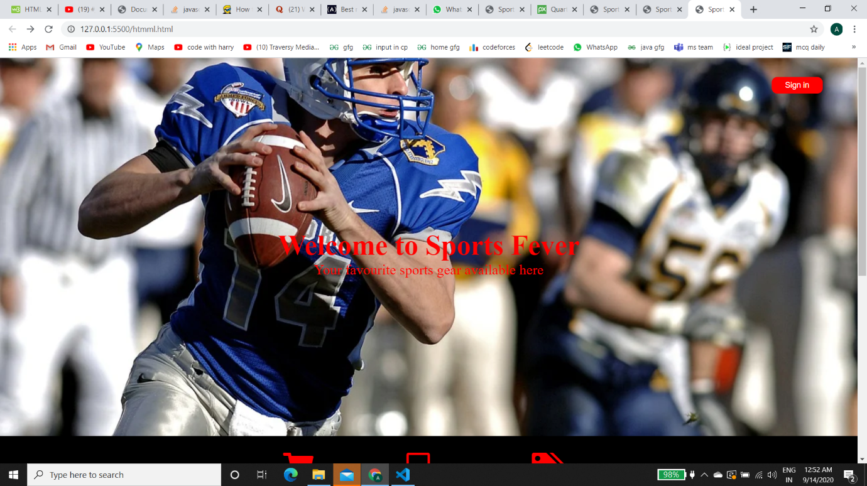

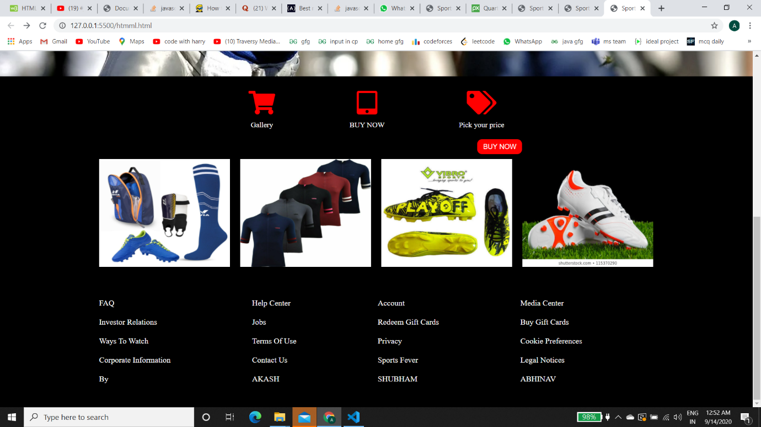

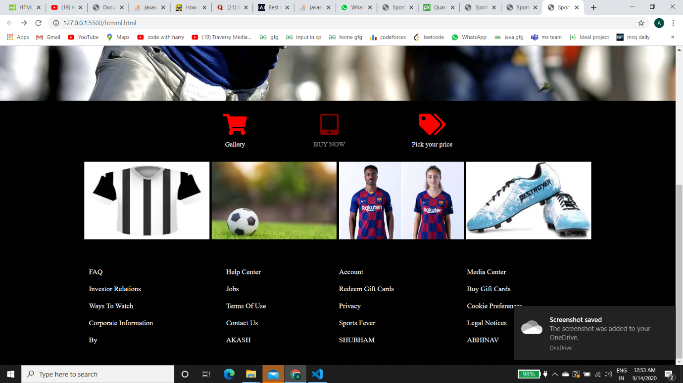

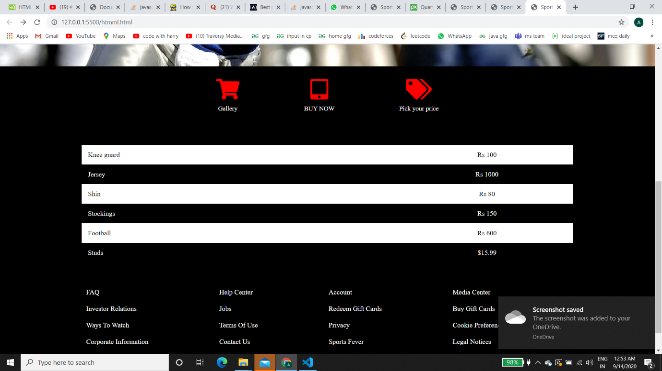

2)Login Page

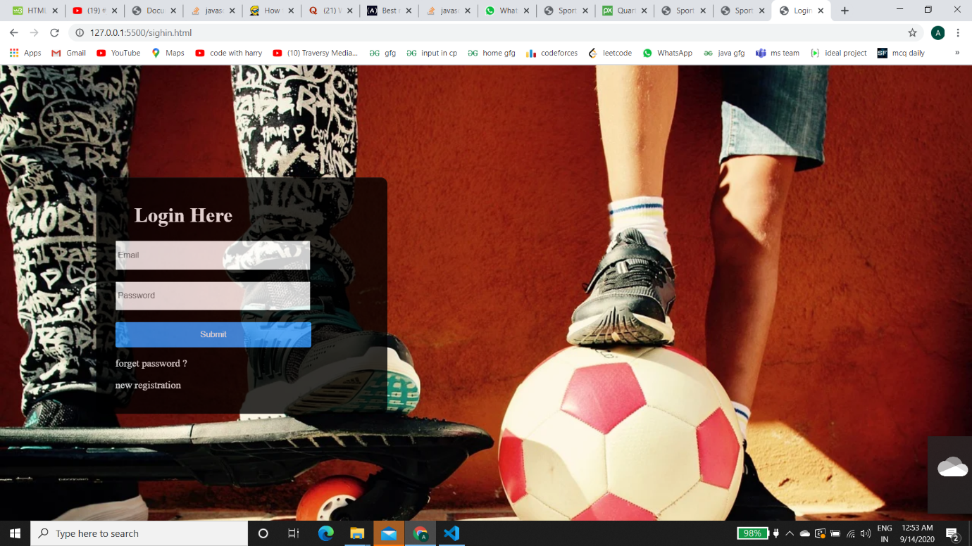

3) Shop now Page

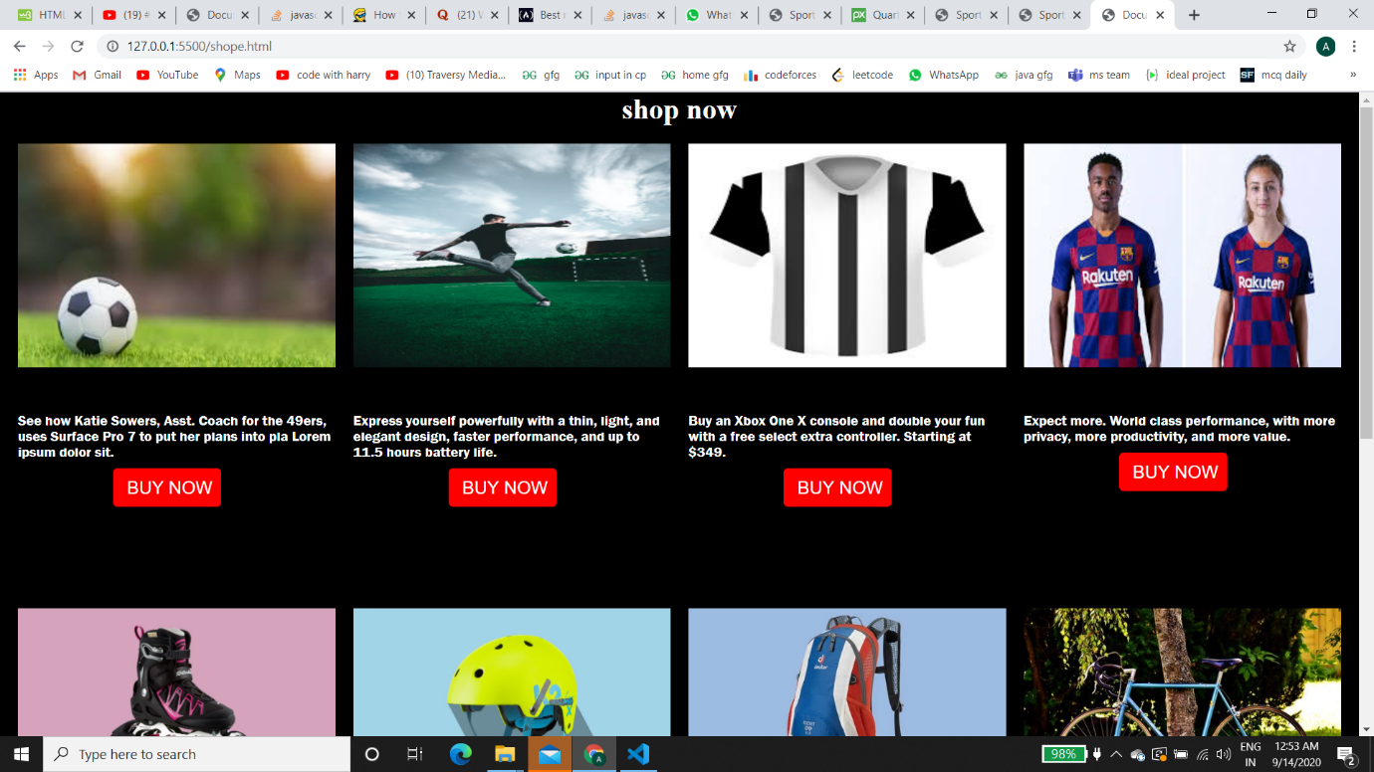

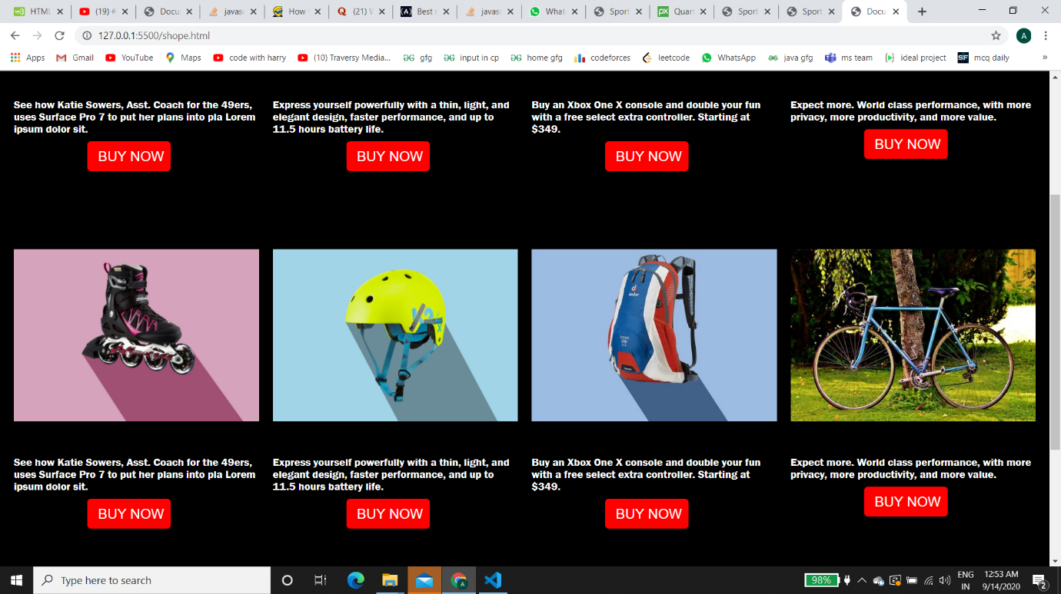

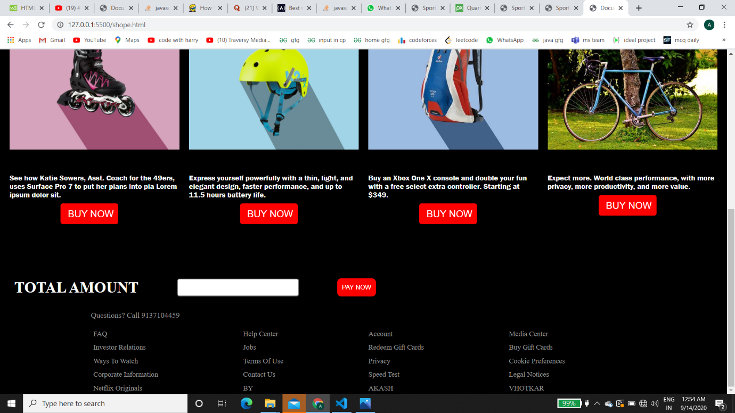

**Conclusion: -**

Hence, the following website was successfully made using html5, css3 and JavaScript.